🧪 CPU Troubleshooting Labs – Exercises

📦 Install below Application for CPU Testing
Below applications will be used to generate real CPU load:

1. Install stress-ng (CPU Load Tool)
sudo yum install epel-release -y
sudo yum install stress-ng -y

Set the stress on CPU and make it run bg process

stress --cpu 4 &

Lab 1 – Total CPU Usage Analysis

Objective
Learn how to check overall CPU usage, CPU idle %, load averages, and CPU saturation.

Commands
top -bn1

Tasks
- Capture the CPU idle %, user %, system %.

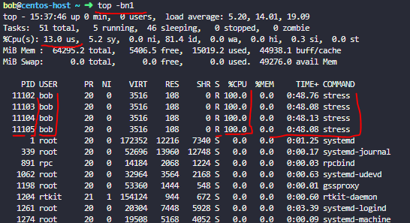

sudo yum install sysstat -y
mpstat 1 5
mpstat -P ALL 1

Tasks
- Identify if system is CPU bound using mpstat.

# if you see %usr high due to stress run by users

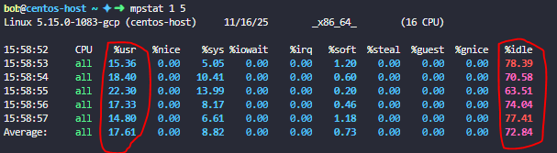
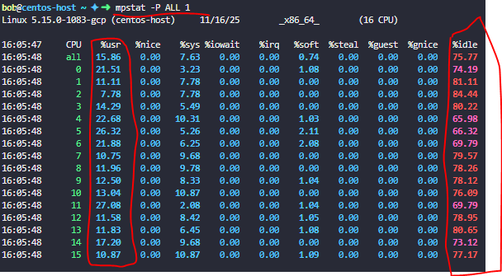

Uptime

Tasks
- Record load average and compare with number of CPUs.
#Load average shows how many processes are waiting OR running on CPU.
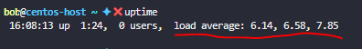

vmstat 1 5

free -h

Tasks
- Check if CPU is waiting for I/O (using vmstat CPU block).

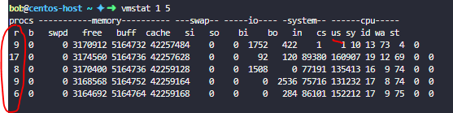

Lab 4 – CPU Usage Over Time

Objective
Monitor CPU usage history.

Commands

pidstat -u 1 5
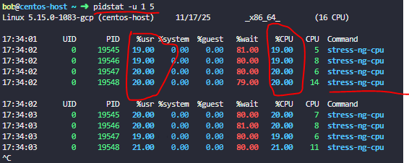
pidstat -C nginx -u 1 5
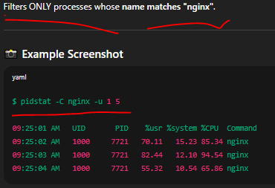
pidstat -p <PID> -u 1 5
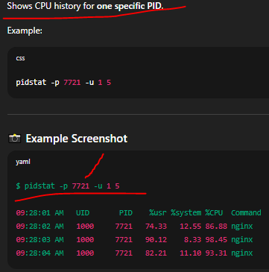
sar -u 1 5

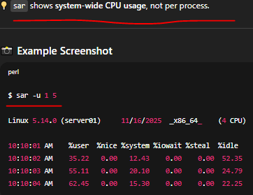

Tasks
- Observe CPU usage over 5 seconds.
- Identify sudden spikes.
- Log results to a file (pidstat -u 1 > cpu.log).

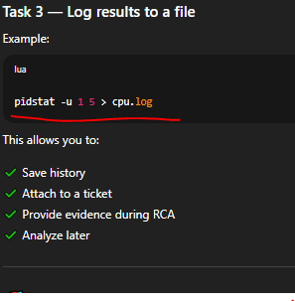

Lab 2 – Per-Process CPU Usage

Objective
Identify which processes are consuming the most CPU.

Commands
ps aux --sort=-%cpu | head

Tasks
- Identify top 3 CPU consuming processes.

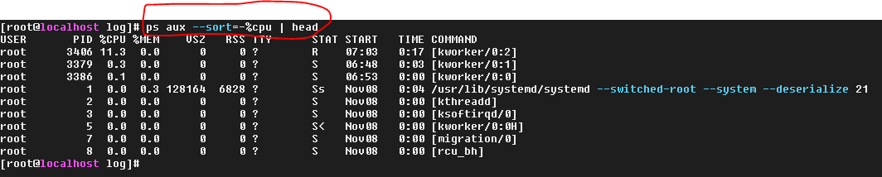
ps -eo pid,ppid,cmd,%cpu --sort=-%cpu | head

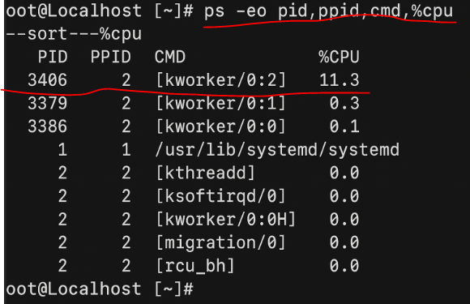

Tasks
- Identify top 3 CPU consuming processes.
- Note their PIDs and %CPU.
- Check command name and parent process.
- Verify if CPU spike is temporary or constant.

Lab 3 – Per-Thread CPU Usage

Objective
Find CPU-intensive threads inside a process.

Commands
top -H
top –H –p <PID> Show threads of specific process

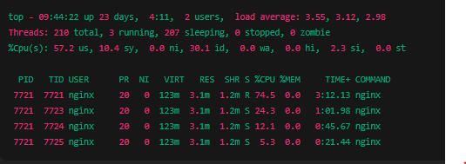

ps -Lp <PID> -o pid,tid,pcpu,psr,comm.

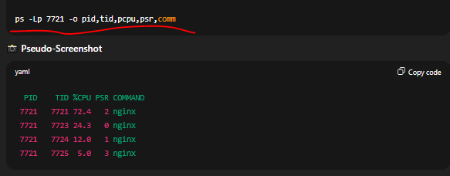

Tasks
- Choose an NGINX, Apache, or stress-ng PID.
- List its threads.
- Identify thread-level CPU spikes.

Lab 5 – CPU Scheduling & Priority

Objective
Understand process priority and CPU scheduling.

Commands
ps -eo pid,ni,cmd --sort=-ni
renice +5 -p <PID>
chrt -p <PID>

Tasks
- Find process nice values.
- Increase nice value of a non-critical process.
- Compare behavior before/after.

Lab 6 – Kernel CPU Stats

Objective
Explore low-level CPU metrics.

Commands
cat /proc/stat
lscpu
grep -R . /sys/devices/system/cpu/cpu*/thermal_throttle

Tasks
- Read CPU context switches.
- Identify CPU model & topology.
- Check if CPU was throttled.

Lab 7 – Application-Level Testing

Objective
Generate CPU load from real apps.

Tasks

NGINX Load Test
for i in {1..100}; do curl -s http://localhost/ > /dev/null & done

Apache Load Test
ab -n 3000 -c 20 http://localhost/

MariaDB CPU Test
mysql -u root -e "SELECT BENCHMARK(20000000,MD5('test'));"

PostgreSQL Test
sudo -u postgres psql -c "SELECT pg_sleep(5);"

Tasks
- Run each workload.
- Observe CPU usage via top, pidstat, thread monitoring.
- Record which application CPU spikes the most.

Lab 8 – System Logs for CPU Issue Diagnosis

Objective
Detect kernel faults, crashes, thermal issues.

Commands
dmesg | tail
dmesg –T | tail
dmesg | grep –i cpu
journalctl -xe --since "10 minutes ago"
journalctl -k | tail
grep . /sys/devices/system/cpu/cpu*/thermal_throttle/*

Tasks
- Check for CPU thermal throttling.
- Identify kernel messages.
- Look for process restarts or service crashes.

